UNIT 1: Map Assignment

Please find and locate the following places on the map provided. (mark the corresponding # on the map of Canada)
- Vancouver
- Edmonton
- Saskatoon
- Grand Rapids
- Norway House
- Churchill
- Ottawa
- Quebec City
- Montreal
- Toronto
- Halifax
- St. John
- St. John’s
- Rankin Inlet
- Winnipeg

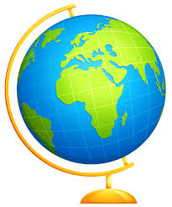

- Regina
- Calgary
- Victoria
- Charlottetown
- Thunder Bay
- Lake Winnipeg
- Atlantic Ocean
- Pacific Ocean
- Hudson Bay
- St. Lawrence River
- Lake Superior
- Arctic Ocean
- Great Slave Lake
- All Provs different colour *( /3.5)
- All Waters Blue *( /3.5)

